ImRotate GUI user manual techlogo-3d  

# System Set-Up

1. Connect DE2 board power supply.
2. Connect DE2 to external display using VGA port.
3. Connect DE2 RS-232 port to PC. Make sure that it connects to port COM4 on PC (else change Matlab GUI code to appropriate port ).
4. Make sure RS-232 is defined to baudrate 115200.
5. Connect JTAG to PC.
6. Power up DE2 Board0
7. Burn the system File "img_man_MDS.sof" to the DE2 card using Quartus Programmer.

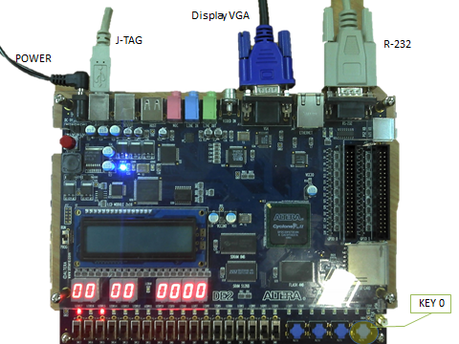

# Operation Sequence

1. Start Matlab and run ImRotateGUI.m.
2. Load images using Load Image button. image should by 512x512 **8bit** greyscale image(bmp/jpeg). Loaded images should in a list below.
3. Choose image from list of loaded images.
4. Choose manipulation parameters:
   1. Rotation angle – any real number.
   2. Zoom Factor – positive 1 up-to 16.
   3. Vertical/Horizontal Start Point– between 1 and 512 (according to input image resolution).
5. Press Transmit Image.

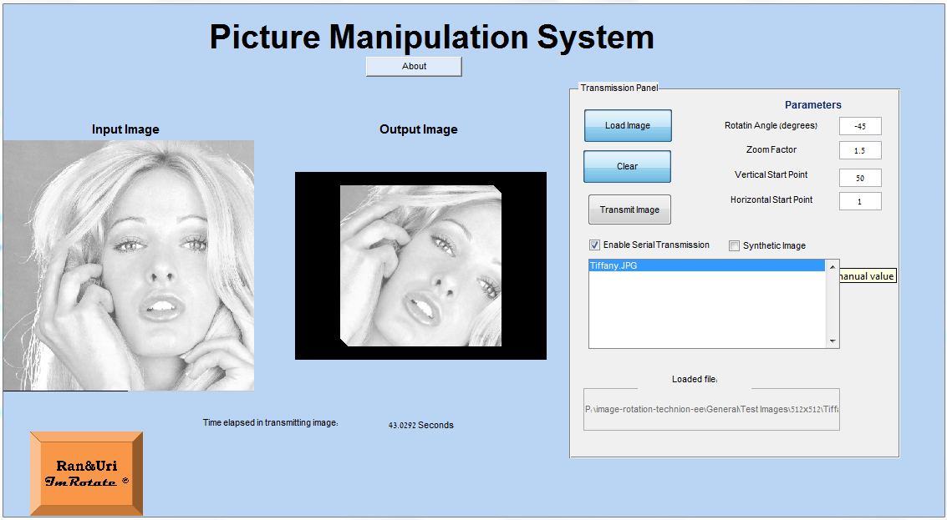

6

4

3

5

2

1. If Synthetic Image option is selected, image will not be displayed. A synthetic generated image will be displayed

# Extra Features

**Switch 0 –**

Down -manual image switching is disabled.

Up – manual image switching enabled.

**Switch 1 –**

Down –display manipulated image.

Up – display original image.

**KEY0**

Reset when pressed